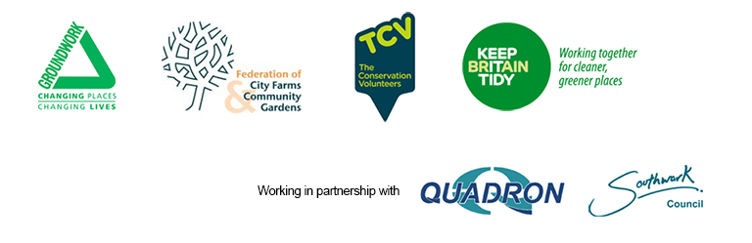

Press release

Embargo: Not for publication before 06.00 on Wednesday October 9 2013

Charities stress health benefits of green space

The health benefits of Britain’s green spaces are in danger of being lost unless politicians and professionals adopt imaginative approaches to their management, a group of leading charities has warned.

The charities say that billions of pounds could be saved and thousands of lives transformed if public open spaces are made an integral part of health policy.

An alliance of environmental charities – Groundwork, Keep Britain Tidy, The Conservation Volunteers and the Federation of City Farms and Community Gardens – says some of the £5bn a year given to local councils to combat obesity, smoking and binge drinking should be used to protect and improve parks and other green spaces.

The charities point to a wealth of evidence that people who have access to quality green space in their neighbourhoods enjoy improved physical and mental health.

They will be pressing the case for the “natural health service” at an event today (Wednesday October 9) attended by the Communities Minister, Stephen Williams, making his first public appearance following this week’s reshuffle, at which he is due to outline the government’s vision for green space. David Walker, the Deputy Chief Medical Officer, will also address the event.

Local Environments Matter, taking place at Burgess Park in Southwark, will be an opportunity for leading figures in the green space movement, along with members of community groups, to question the minister on the future of Britain’s green spaces as council budgets face severe pressure.

Speaking on behalf of the four charities, Jeremy Iles, Chief Executive of the Federation of City Farms and Community Gardens, said: “There are some straightforward connections to be made as we discuss green space, health and public finance: people need parks, parks need money.

“I hope that by now we are past the need to convince people of the social benefits of green space, but we still need to press the case around the impact parks can have on the health of the nation.

“We want local authorities, national government, the health sector and charities like us to work together to make the most of what funds are available to preserve and improve our urban green space.

“Money earmarked for public health need not only be spent on clinics and poster campaigns; why not use some to develop local parks as outdoor medical centres, resources for exercise, relaxation and social interaction?

“Over the last 15 years the UK has witnessed a renaissance in the quality of its green spaces and local environments. Every year, dedicated park managers and staff supported by hundreds of thousands of volunteers and community groups, reclaim, protect and improve spaces that matter to us all.

“Our 'green infrastructure' is part of what makes Britain great. It improves our health, reflects our culture and brings people of all ages and backgrounds together. It also increasingly helps us mitigate the impacts of climate change and support business investment.

“But times are changing. Public spending cuts are making it harder to preserve quality. Local communities are being encouraged to do more but need help and support. All agree that we mustn't lose the progress that has been made.

“We want to ensure this vital subject remains high on local and national government agendas and at the heart of business thinking on social responsibility.”

Also today’s event, will see the announcement of the winner of the Green Flag People's Choice Award recognising the UK’s favourite Green Flag Award park or green space.

A record breaking 1,448 parks and green spaces this year received a Green Flag Award and since the official awards were announced in July, people across the country have been voting for their favourite park with 2013 seeing a record number of votes cast.

The Minister will formally announce the top three sites across the country and which site has been crowned the ‘People’s Park of the Year’.
Local Environments Matter is supported by Quadron and Southwark Council.

Ends

Issued on behalf of Groundwork, The Conservation Volunteers, Keep Britain Tidy, Federation of City Farms and Community Gardens

By Chris Burton
PR Assistant
Groundwork UK
Switchboard: 0121 236 8565/Direct Dial: 0121 237 5874
Mobile: 07788 314485
Lockside, 5 Scotland Street, Birmingham B1 2RR

Notes to Editors

The Conservation Volunteers, Federation of City Farms and Community Gardens, Groundwork and Keep Britain Tidy have nearly 180 years of combined experience of creating and maintaining better places for everyone to enjoy.

The Conservation Volunteers help hundreds of thousands of people each year to reclaim local green places. Through their environmental projects and network of 2,000 community groups, they see people – every day, and all across the UK – taking responsibility for their own local environments.
www.tcv.org.uk

The Federation of City Farms and Community Gardens was founded in 1980. We represent and promote the benefits of a wide range of grass-roots community groups across the UK, from large city farms to community allotments and gardens, care farms and school farms amongst others. Our Federal structure and ethos ensure that we work to empower our members and the communities and individuals they serve.
www.farmgarden.org.uk

Groundwork is the community charity with a green heart. We want places to look better, streets to be safer and outside areas to be green and beautiful. We want people of all ages to be able to do stuff together to make the best of where they live. We want to improve job prospects by offering training and employment opportunities. We want to show people how they can make their homes and workplaces better for the environment and cheaper to run.
www.groundwork.org.uk

Keep Britain Tidy is a leading environmental charity. We inspire people to be litter-free, to waste less and to live more. We run programmes including Eco-Schools, the Green Flag Award for parks and green spaces and the Blue Flag/ Seaside Awards for beaches.
www.keepbritaintidy.org

The Green Flag Award scheme is licensed to Keep Britain Tidy, from the Department for Communities and Local Government, and managed across the UK in partnership with Keep Scotland Beautiful, Keep Wales Tidy and Tidy Northern Ireland, the Federation of City Farms and Community Gardens and the National Housing Federation.

