

Effective Volunteer Manager
Programme
2013

Welcome to your Workbook!

Please use the resources within this manual to maximise the training in which you are participating

We hope you enjoy the workshop you are about to take part in.

Participate
Join in
Ask questions
Help each other
Have fun!

Course Objectives

By the end of the workshop you will be able to:

Recognise the positive managerial and leadership behaviours that drive the organisation forward

Demonstrate two way evaluation of task and mutual performance goals

- Set quality objectives using the SMART model

- Motivate your volunteer team members appropriately to get the best out of them

- Give excellent quality feedback

- Deal effectively and professionally with the more challenging conversations

What are your personal objectives for attending today?

What are the IDEAL Leadership Behaviours?

Notes


What is the benefit of a balanced approach?
Notes
“There is a profound difference between management and leadership, and both are important. To manage means to bring about, to accomplish, to have charge of or responsibility for, to conduct. Leading is influencing, guiding in a direction, course, action, opinion. The distinction is crucial” – Warren Bennis
The manager administers; the leader innovates.
The manager is a copy; the leader is an original.
The manager maintains; the leader develops.
The manager focuses on systems and structure; the leader focuses on people.
The manager relies on control; the leader inspires trust.
The manager accepts reality; the leader investigates it.
The manager has a short-range view; the leader has a long-range perspective.
The manager asks how and when; the leader asks what and why.
The manager has his or her eye always on the bottom line; the leader has his or her eye on the horizon.
The manager imitates; the leader originates.
The manager accepts the status quo; the leader challenges it.
The manager is the classic good soldier; the leader is his or her own person.
The manager does things right; the leader does the right thing.

What Behaviours Make a Successful Volunteer Manager?

Notes


Setting Quality Objectives

S Specific and Measurable
M Motivational
A Attainable
R Relevant
T Trackable

Notes

Which Values and Behaviours are we demonstrating by setting clear objectives?
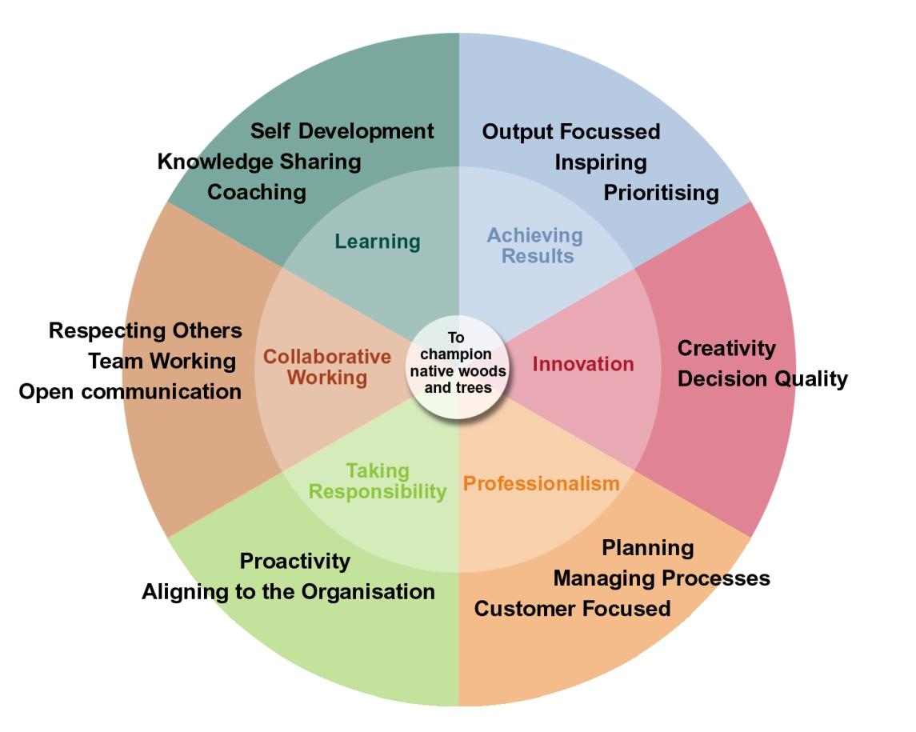

Barrier to an effective Review | How to overcome the barrier
Best Practice Ideas

Notes

What DRIVES You?

Notes

Motivation

Conscious Competence Learning Model (Development Ladder)

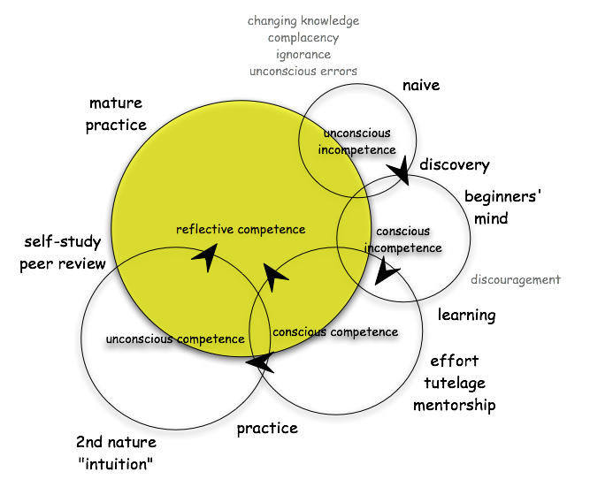

Courtesy of Will Taylor, Chair, Department of Homeopathic Medicine, National College of Natural Medicine, Portland, Oregon, USA, March 2007.

The Development Ladder
Steps on the ladder | How to motivate them
Unconscious Competence
Conscious Competence
Conscious Incompetence
Unconscious Incompetence

Linking volunteers to the Values and Behaviours Wheel

What are your volunteer team’s development areas?
Learning
Achieving Results
Innovation
Professionalism
Taking Responsibility
Collaborative Working

Create SMART Objectives for your volunteer team members
Remember to:
Identify what drives (motivates) them
Think of the guidance you may need to give
Think of what development needs the individual may have in order to succeed

TEAM MEMBER | OBJECTIVE

Impact of Our Communication

Words

Tone of Voice

Body Language

Effective Communication
“If people are our most important resource, then rapport is the way to tap that resource…[it’s] the ability to form a powerful common human bond and a relationship of responsiveness… A lot of people make life very complicated and difficult. It doesn’t have to be… no matter what you want to do, see, create, share or experience in life… there’s someone else who can help you accomplish your goal more quickly and easily… who knows how to get here quicker or more effectively or who can help you get where you want to go more rapidly and the way to enlist that person is to achieve rapport, the magic bond that unites people and makes them feel like partners.”

Anthony Robbins – ‘Unlimited Power’ ch 13 – “The Magic of Rapport”
How do you build rapport?

Notes

Fighting Words

Notes

Giving Good Quality Feedback

A ction
I mpact
D esired Result (Do)

M onitor
E valuate

Giving Feedback

Notes

Effective Questioning
Task | Capability | Motivation

The EAR Model

E xplore

A cknowledge

R espond

Someone says or does something

Do I truly understand or have enough info?

Why is that?
Tell me more
In what way?
NO
EXPLORE

YES

ACKNOWLEDGE
The person’s feelings and concerns
So what you're saying is...
Sounds like...
You’re concerned that...

Let the person respond

What ideas do you have for resolving this?
Let me explain my reasoning
Here’s what I’d recommend
RESPOND back to the person

EAR Model Conversation Starters

Exploring
Conversation Encouragers
- Oh?
- Tell me more
- Really?
- Hmmm...

Discovery Questions
What, when, where, why, how
- In what way?
- Why’s that?
- What ideas do you have?
- How should we solve this?

Acknowledging
Paraphrasing
- You’re concerned that...
- In your opinion...
- So what you’re saying is...
- What you’d like is...

Reflecting Feelings
- You’re frustrated because...
- Sounds like...
- That’s gotta be...
- Gee, if I were you I’d be feeling...

Summarising
- Let me see if I understand what I’ve heard so far...
- If I were to summarise what you said...
- Let me play back what I’ve heard so far...

Listening

THEM | TALKING
YOU | LISTEN | REACT | LISTEN | RESPONDING | LISTEN | REHEARSE | LISTEN

Handling the Challenging Conversations Effectively
The Behavioural Iceberg

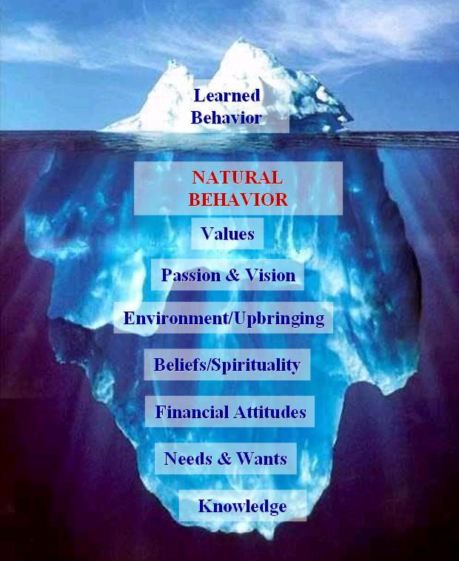
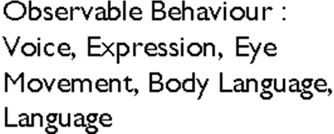



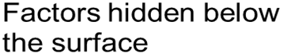

What are the reasons behind conflict?

Notes

Transactional Analysis
Transactional analysis is one of the most accessible theories of modern psychology. It was founded by Eric Berne and the famous ‘Parent Adult Child’ theory is still used today. Berne began to develop his theories of TA in the 1950’s. He said that verbal communication, particularly face to face is at the centre of human social relationships and psychoanalysis.
His starting point was that when two people encounter each other, one of them would speak to the other. TA became the method of examining the transaction wherein: ‘I do something to you, and you do something back’

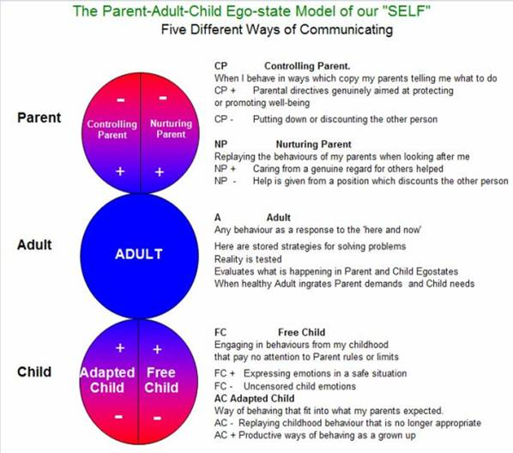

Notes

Your Action Plan
What will you do differently going forwards?

What will you continue to do that is working well?

What will you stop doing?

It is important you discuss this with your line manager within the next 2 weeks.

Recommended Books, Articles & Web Sites

Books
Caplan, J. (2003). Coaching for the future: how smart companies use coaching and mentoring

Downey, M (1995). Effective Coaching.

Whitmore, J. (2002). Coaching For Performance: Growing People, Performance & Purpose (3rd Edition)

Websites
www.businessballs.com – A wealth of information, theories, exercises and articles on management, leadership and coaching

